ASSIGNMENT NO-01

Problem Statement:-**Create an account in AWS and configure a Budget.**

* **Steps for creating an AWS account:-**

1. Go to the AWS homepage at https://aws.amazon.com/ and click on the "Create an AWS Account".

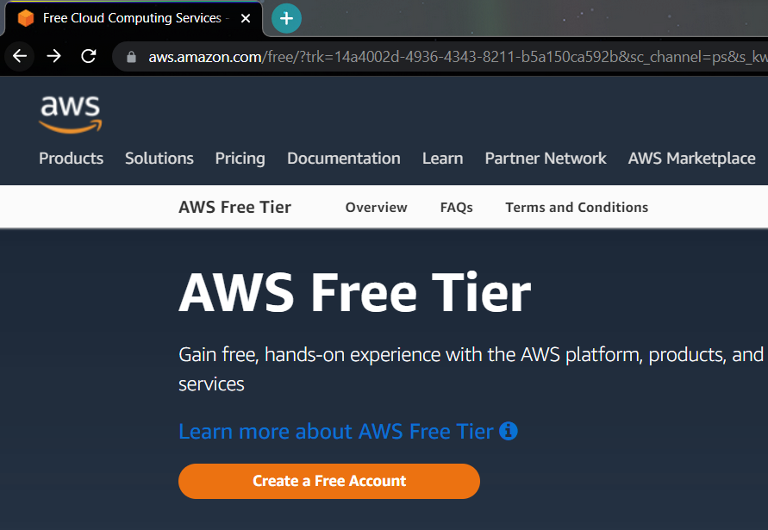

1. Enter root user email address and AWS account name then verify the email address.

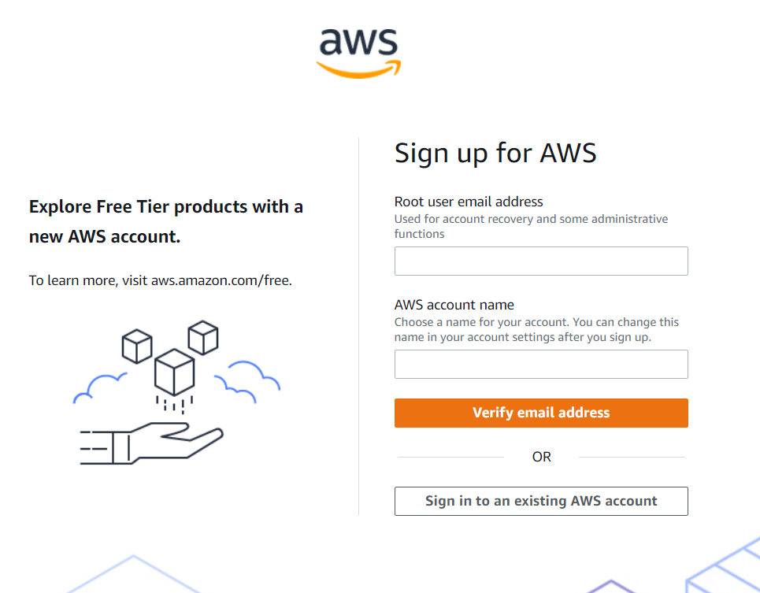

1. After verification enter root user password and continue.

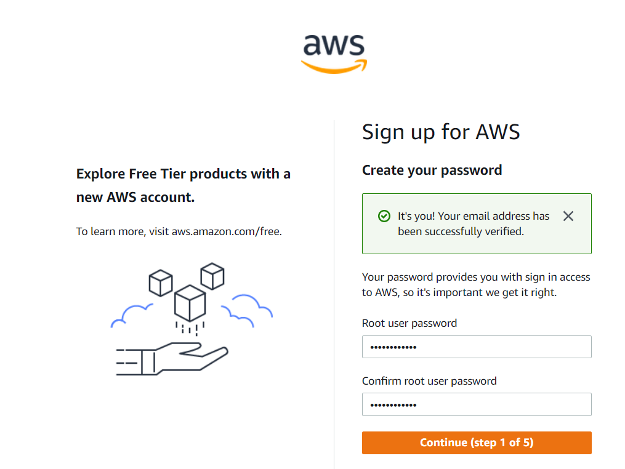

1. Contact Information  
   Select your AWS type (Profesional/ Personal) Fill in the correct information to validate your account if you’re going to create personal use then click on “Personal Account” else use “Company Account”, Accepts the Terms and  
   condition and then click on Create Account and Continue.

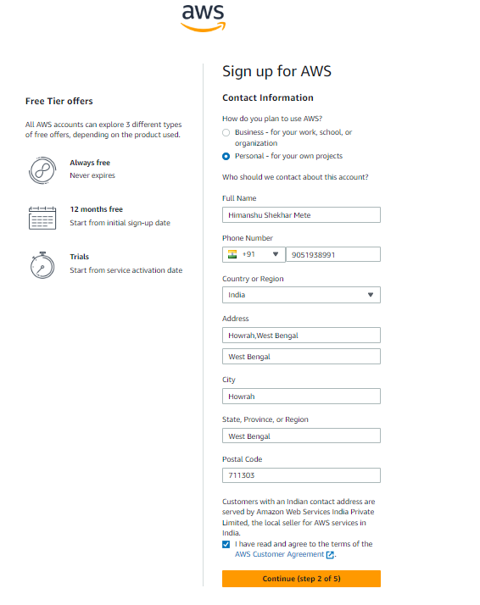

1. Payment and PAN information: In this step, you must fill in your credit card /Debit Card info and billing address and click on Secure Submit.

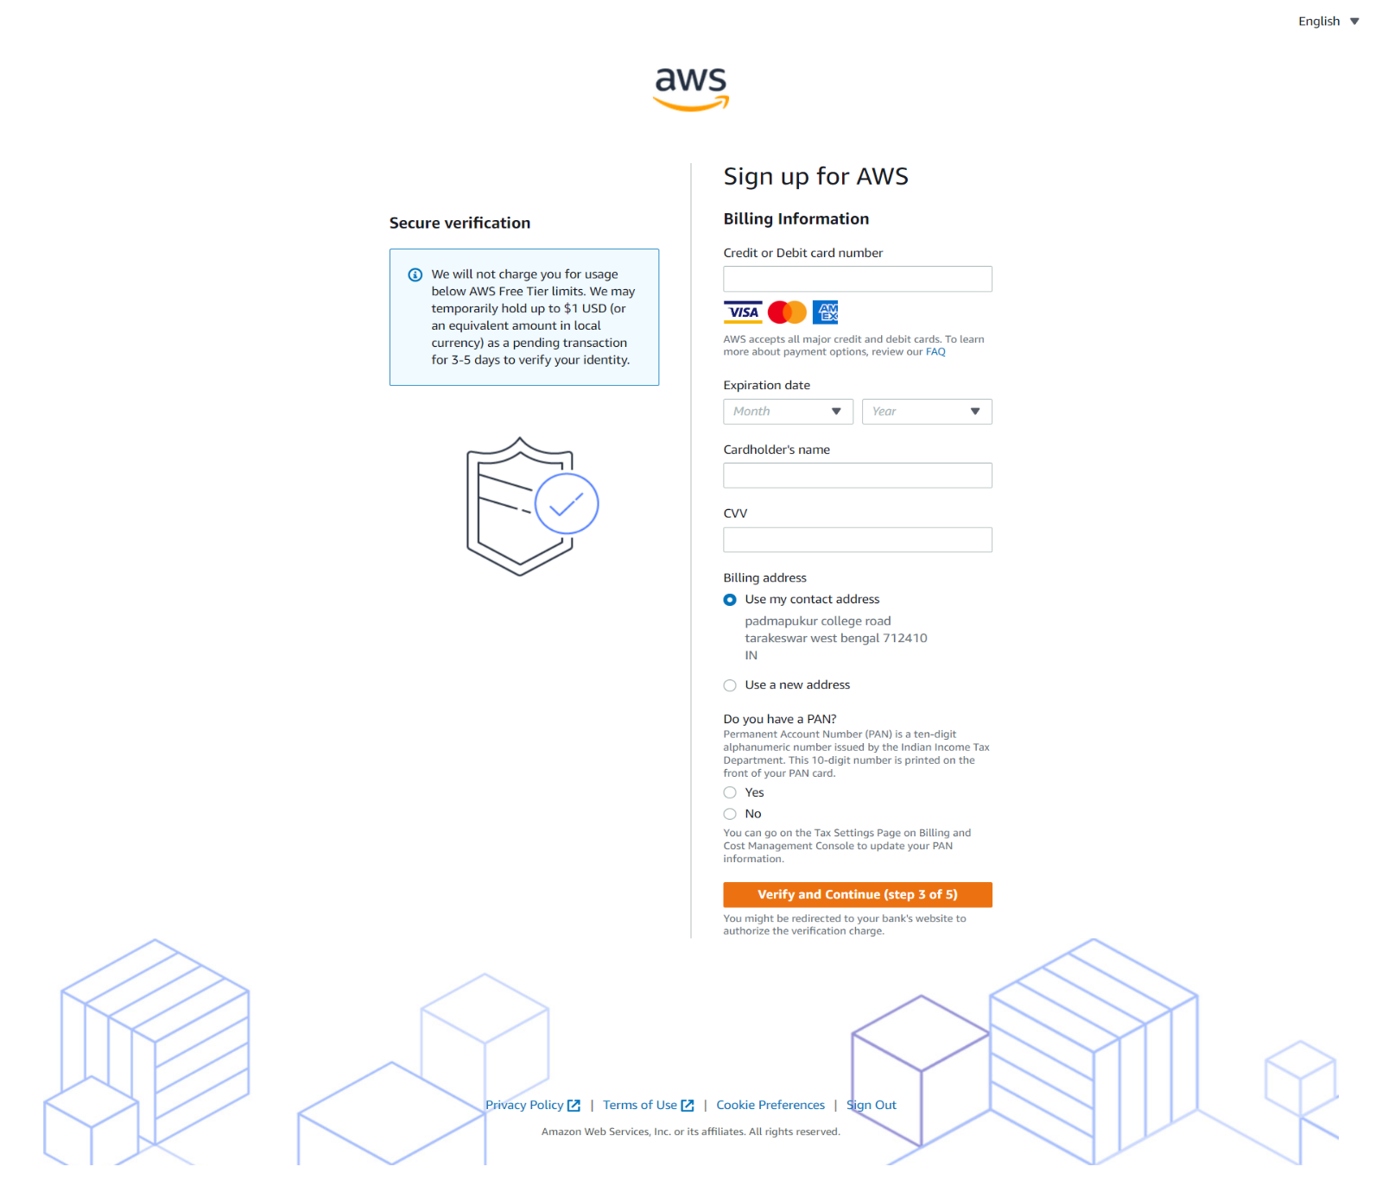

1. In this step, it will take you to the payment gateway to validate your payment information and for your credit card verification, Amazon will charge the minimum price based on Country. Here I have provided India, so Amazon charged 2 INR. 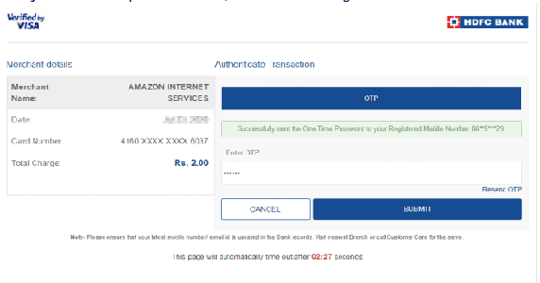
2. Phone verification: Here you will be taken to an identity verification page that will already have your phone number, so you just have to select either “Text message or Voice call” Provide a valid phone number, Solve the captcha, and then click on Send SMS or Call Me Now(depending upon your selection).

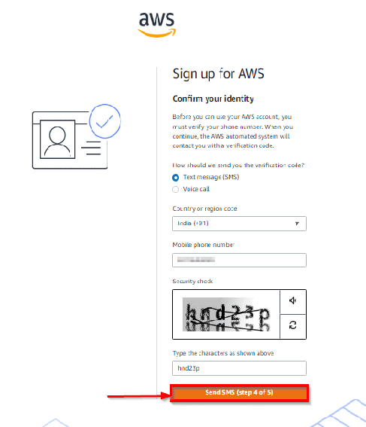

1. After clicking on Send SMS or Call me Now, you will immediately receive a call or SMS from Amazon, for verification code, Enter your code then click on Verify Code. 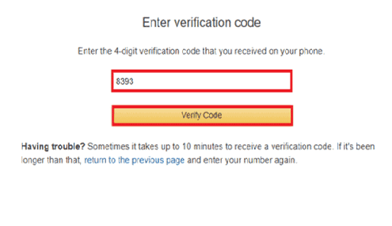
2. Support plan: AWS support offers a selection of plans to meet your business needs.  
   Select your suitable plan then click continue.

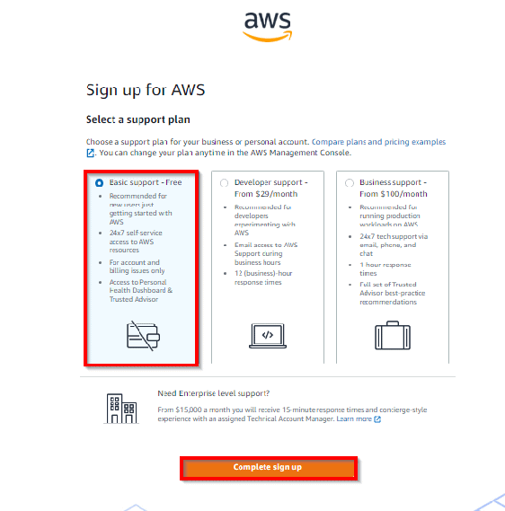

1. Registration Confirmation page

Once you completed all the above steps and processes. You’ll get the confirmation page as below. Now your account will be processed for activation. It may take somewhere between 30 minutes to 1 hour for you to receive an email confirmation that your Amazon Cloud Services account has been activated. 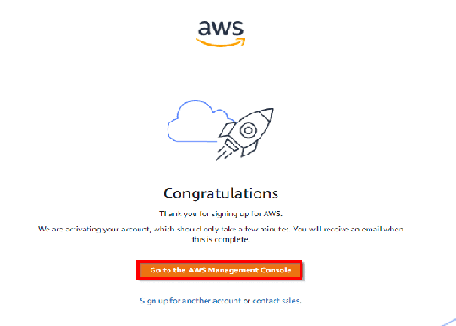

* **Steps for creating a Budget :-**

1. Click on the account profile name on the top right corner and click “Billing Dashboard”.

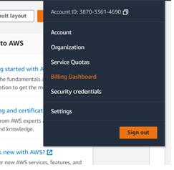

1. Click on budgets on the left side in “Cost Management” section.

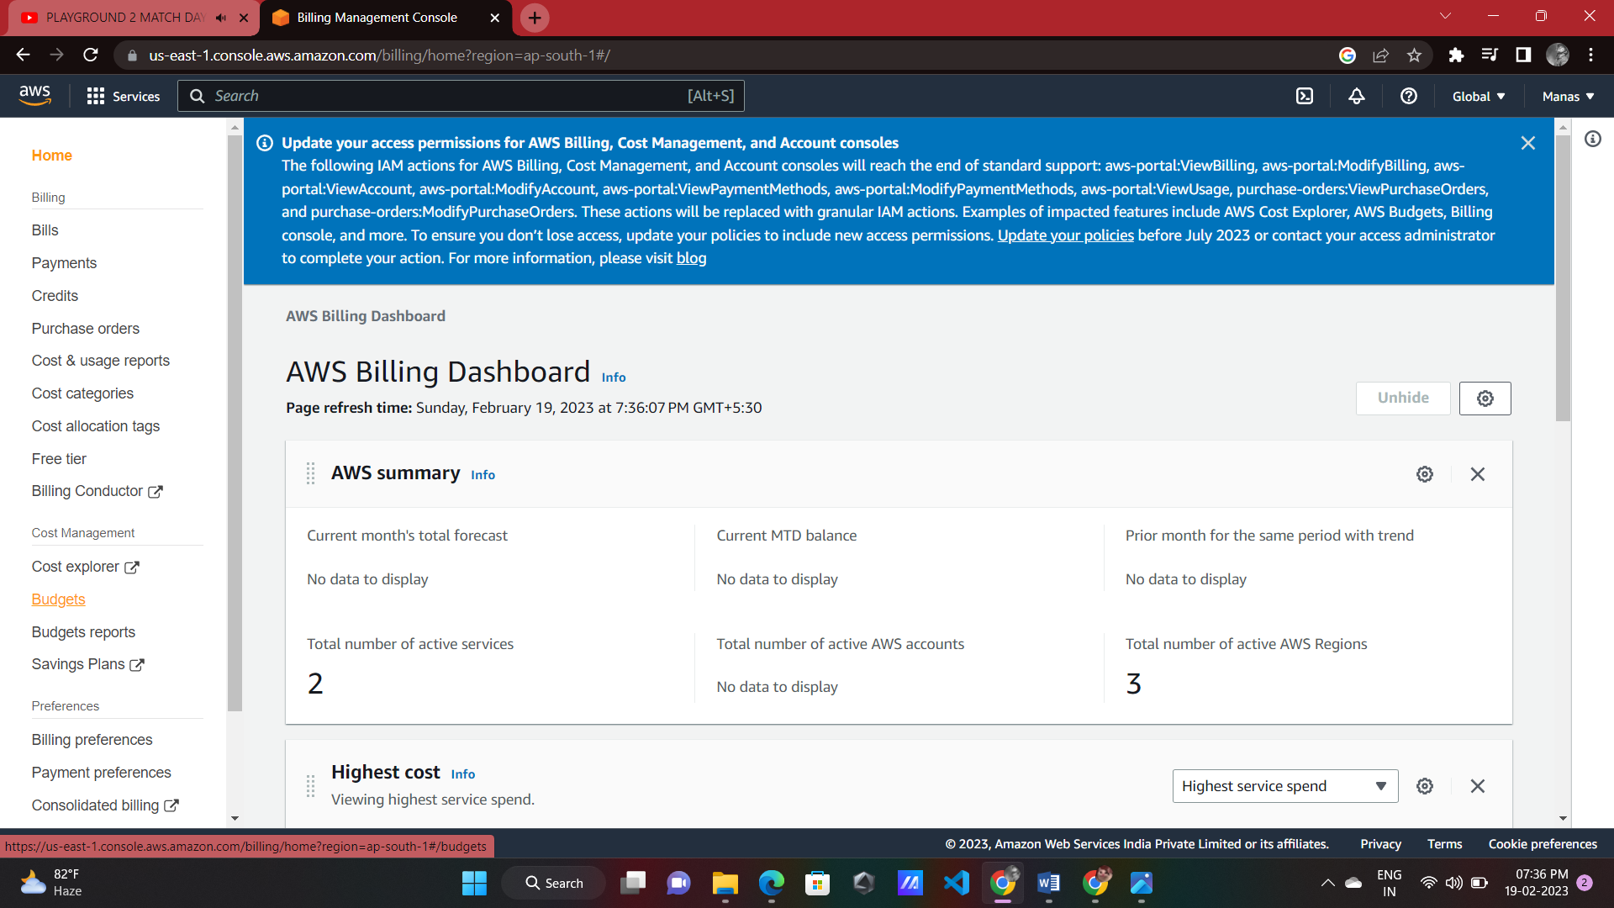

1. Click “Create Budget”.

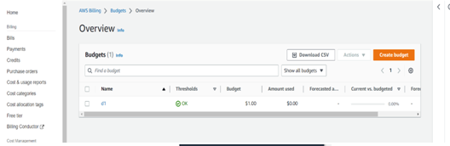

1. Click on “Customize (advanced)” and rest will be as it is and click next.

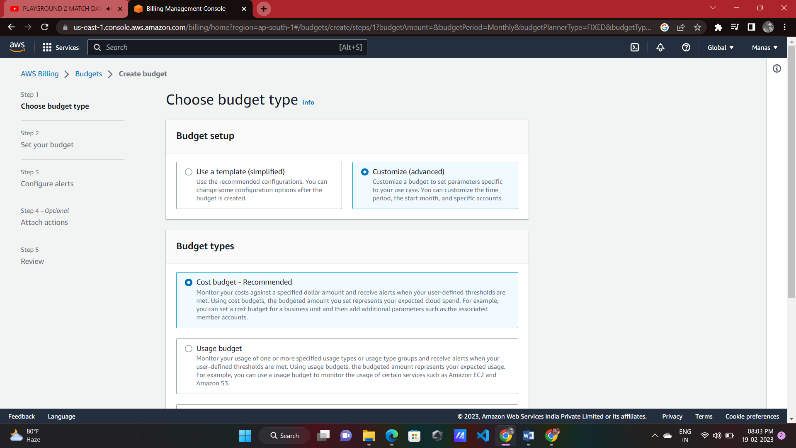

1. Enter budget name.

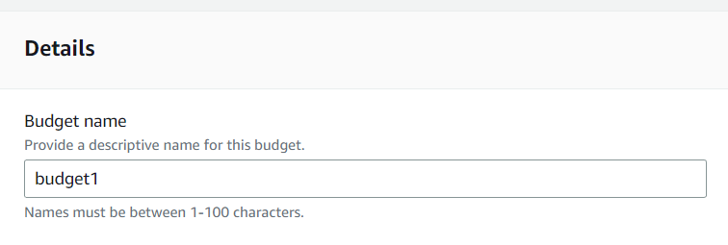

1. Set period , budgeted amount, budget type according to user’s choice .

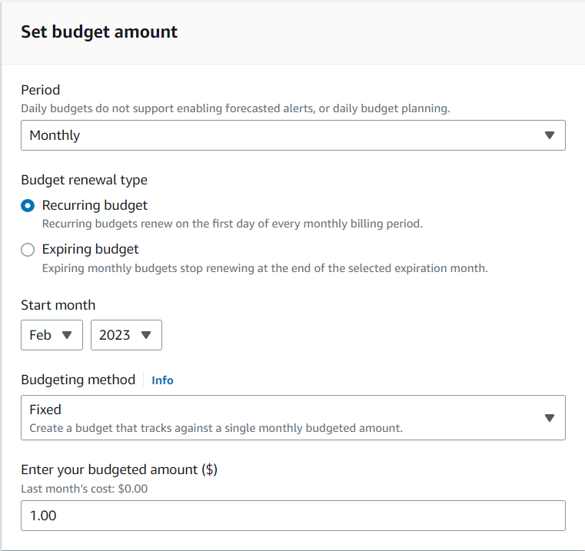

1. Set “alert threshold” according to user and click next .

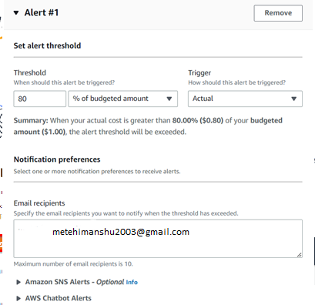

1. Review budget and click “Create Budget”. 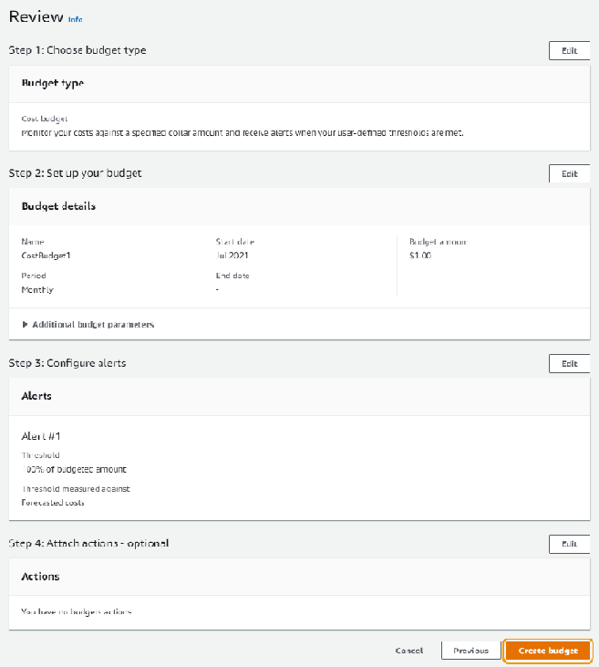

Now, Budget is configured and created and user can download details by click on “Download CSV”. User can review budget and edit at any time.

ASSIGNMENT NO-02

Problem Statement:-**Create MFA for authentication.**

* **Steps to add MFA Authentication:-**

1. At the top right corner click on account profile and click on “Security Credentials”.

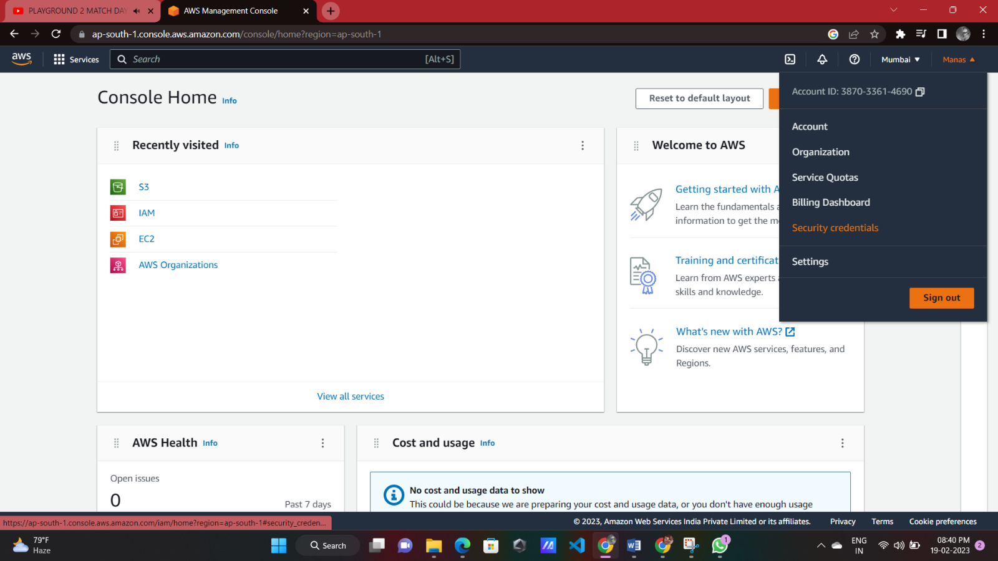

1. Click on “Assign MFA Device”.

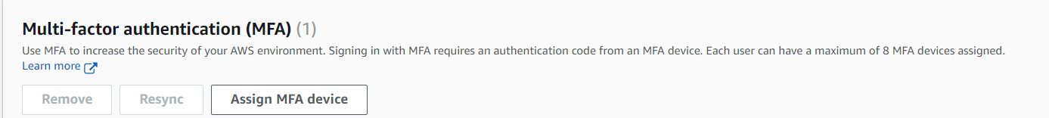

1. Specify a name in Device name and click NEXT.

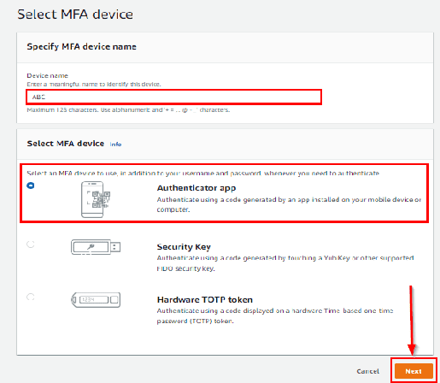

1. Now Install Google Authenticator on your phone.Then Click on Show QR Code and open the Google Authenticator app on your phone.

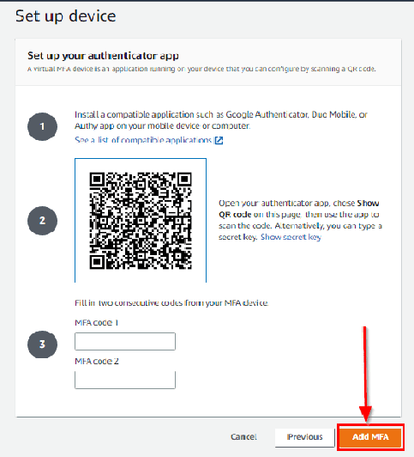

1. Now open the Google Authenticator App Click on Get started and Scan the QR code.

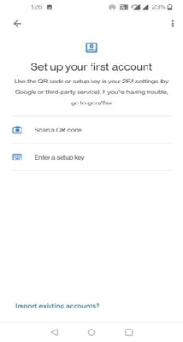

1. Now Enter the code from your Phone into MFA code 1 and MFA code 2. After adding MFA code click on Assign MFA. 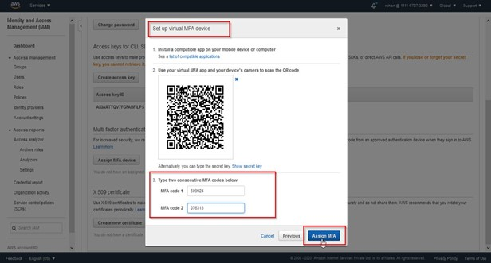
2. You will get a success message then click on Close. 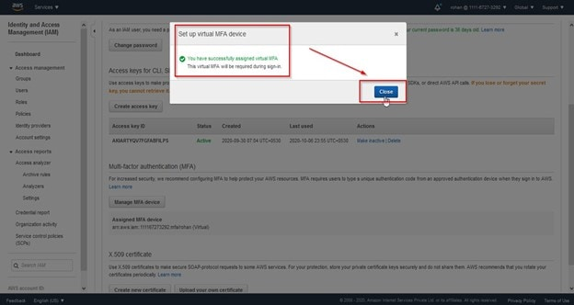
3. Now you will see that the device has been added for MFA. 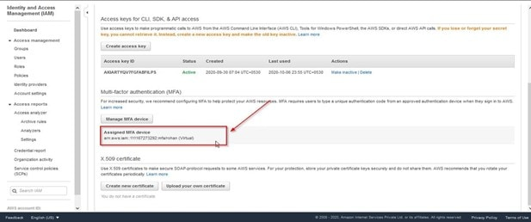
4. Now you have successfully **Activated MFA on your root account**setting.

## ****Accessing AWS Console Using MFA****

1. Open your AWS console login page and click on **Root User**then enter your email.

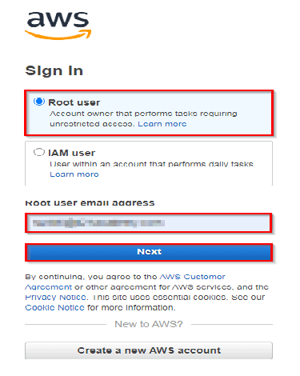

1. Enter your password corresponding to the Email address.

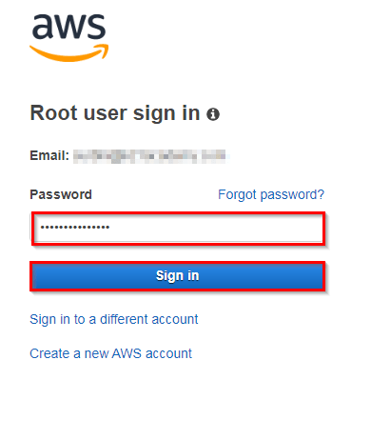

1. Use your **Google Authenticator**Application on mobile and enter MFA code in AWS Console.

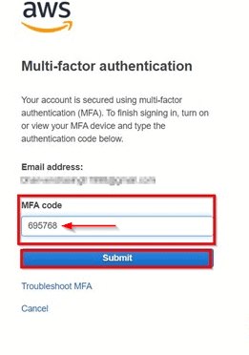

Now, Multi-Factor Authentication (MFA) is set up for user’s AWS account, which adds an extra layer of security to help protect user’s account from unauthorized access.

ASSIGNMENT NO-03

Problem Statement:-**Create IAM user and thereby give full access of S3.**

* **Steps for creating IAM user and giving full access for S3 permission:**

1. In the account click on search section and type “IAM” and click on “IAM”.

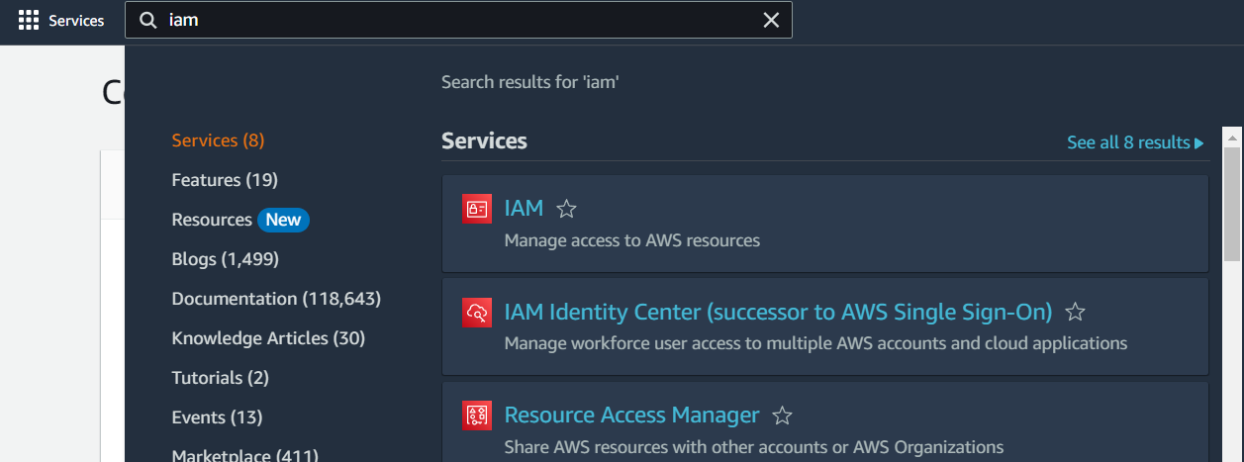

1. Click on “Users” in the right side of the page.

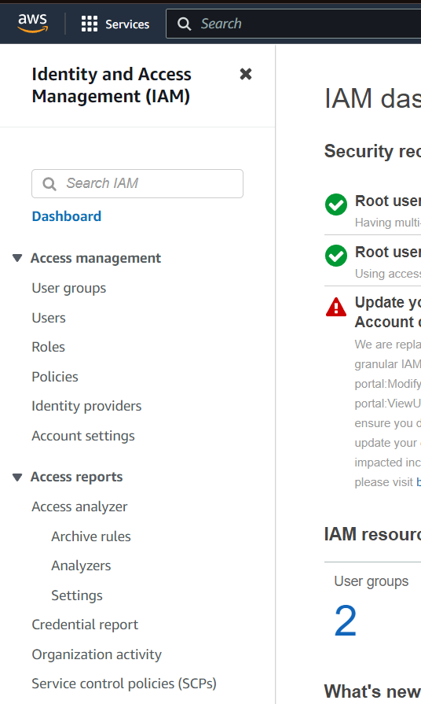

1. Click on “Add Users”.

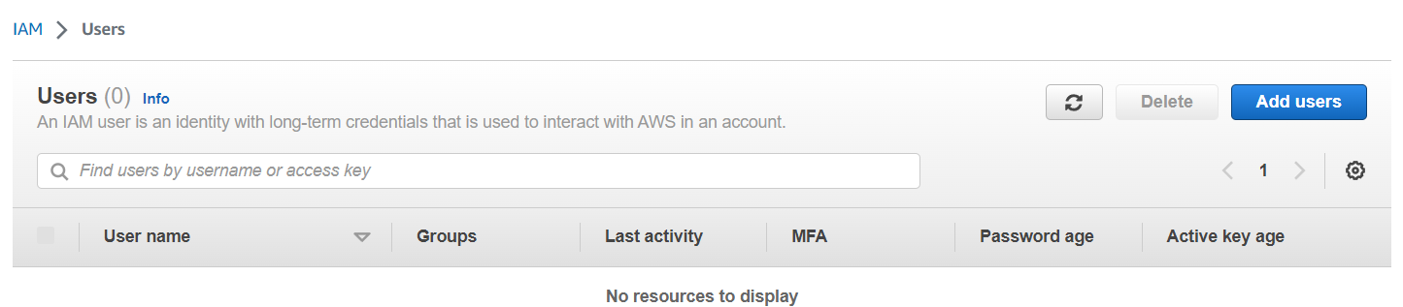

1. Then add user name and click the check box to provide console access and click “I want to create an IAM user” and give custom password and click next .

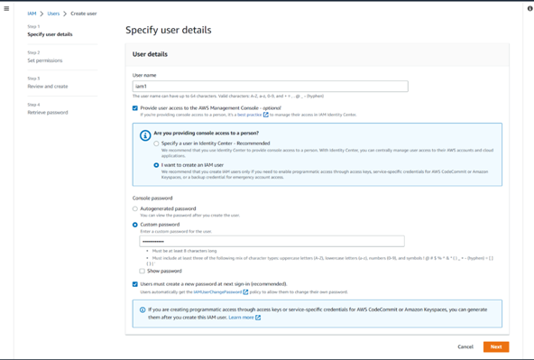

1. In User Group section click Create Group and enter User group name and give permissions of S3 and click create User group and add that group and click next .

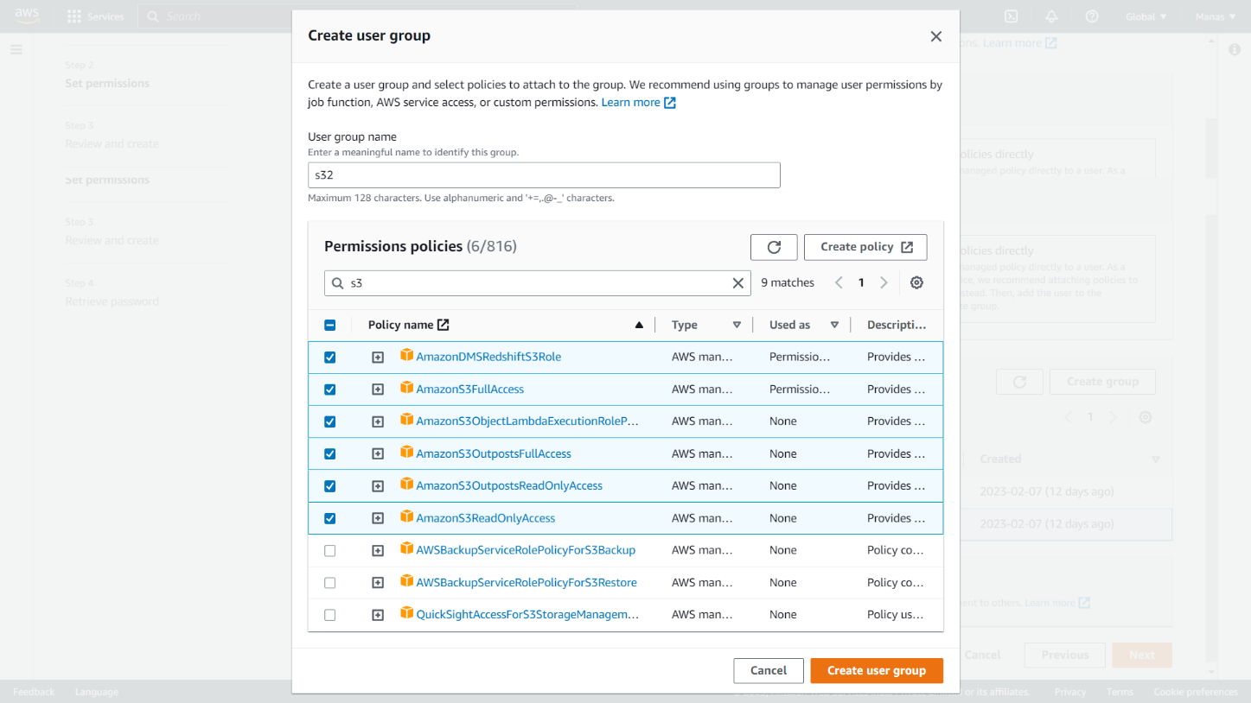

1. Review options and click on Create User. Click on the “Download .csv file” to get the credentials of users. And Click Return to users list.

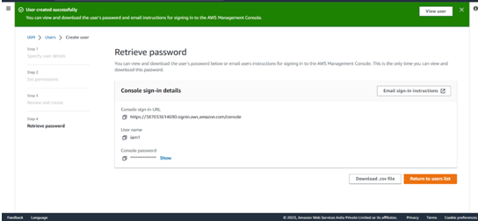

1. After returning click on IAM user name (ex-iam1) and go to “security credentials” and copy Console sign-in link and paste it in another tab of chrome or any search engine.

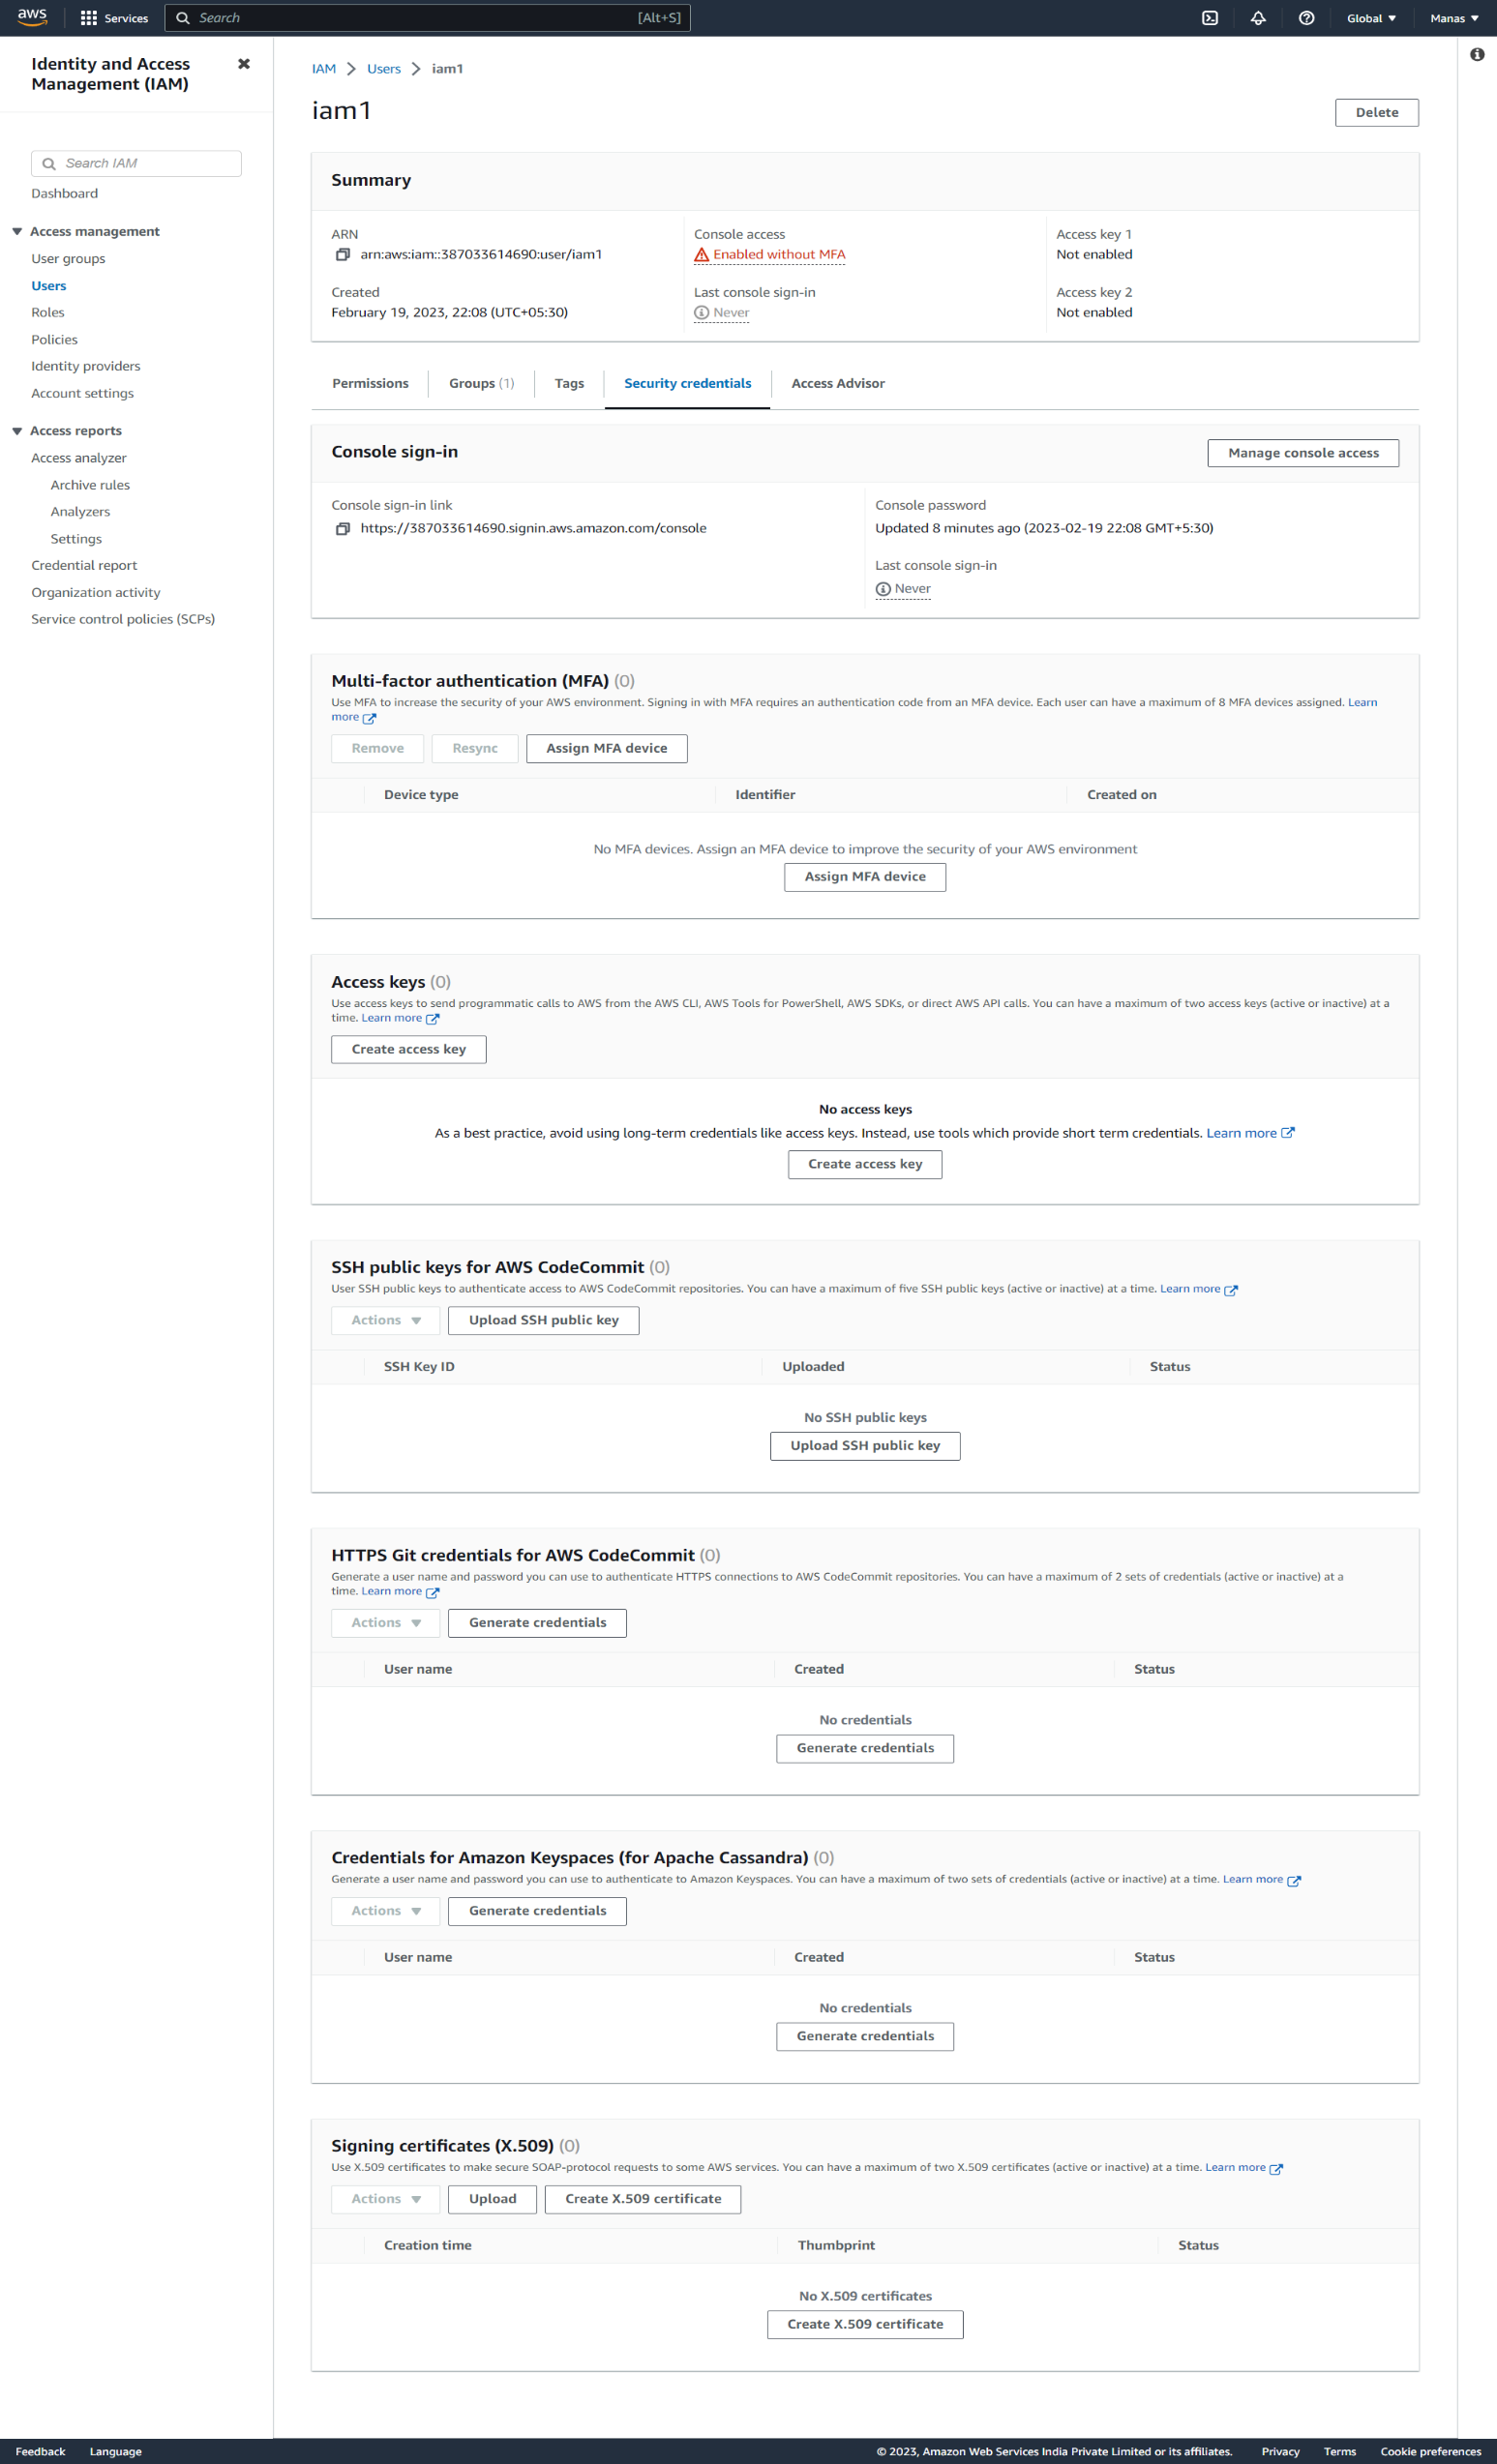

1. After opening the console link user should give relevant details and next user has to change the password and after changing it will open to the IAM user account.

